Dear Student,

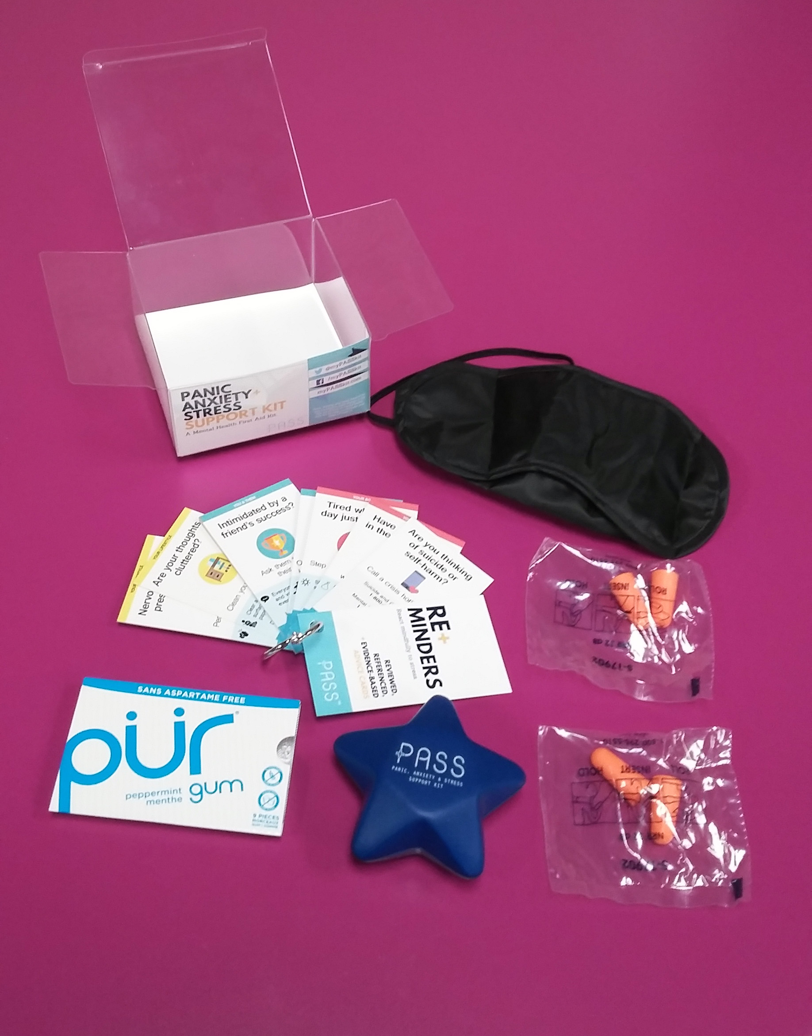
The COVID-19 pandemic has caused many people to feel more stress and anxiety than normal, due to financial strain, health anxiety, and isolation. On top of this, many students will be studying remotely this term, which can be challenging and may add to the stress students are already feeling. To support its community during this difficult time, [School Name, Department] has decided to purchase a PASS Kit for each student member. Due to the remote nature of classes, we ask you to provide a preferred address for us to ship the PASS Kit to at the end of this letter. PASS kits can be shipped to anywhere Canada Post delivers to at a given time. This will not update your current mailing address on school records or redirect any future mail from the school.

The PASS Kit is a self-care tool for communities and individuals to manage daily stressors. It contains flashcards with concise mental health advice, earplugs for blocking uncomfortable noises, a foam star to grip and release to relax tense muscles, a sleeping mask for shielding disturbing lights, and chewing gum to chew for focus and for refreshment. The PASS Kit was designed with student and expert feedback based on Cognitive-Behavioural Therapy principles. More information is available at mypasskit.com

To opt-in to receive a PASS Kit, please check only one of the options below, and fill in a shipping address:

❐ Yes, please send me a PASS Kit (including Re+minders flashcards)
❐ Yes, please send me ONLY the Re+minders flashcards

Full Name |  | Student/Employee ID
Street Address | Unit (if applicable) | City
Province/State | Country | Postal Code/ZIP Code

